**SOP for optimizing Filesystem warning in MLModels - CISRE – NLP instance**

Step -1:

Login to the instance

Step -2:

Put the following command

* du -sh *

You will get the following folder which is utilizing more space.

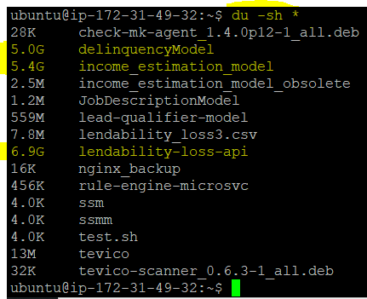

Step -3:

Change the directory to highlighted folders one by one.

You will able to see the logs folder



Step -4:

Change the directory to logs

Put the following command

* ls -lhrt

You will see the unzipped log file

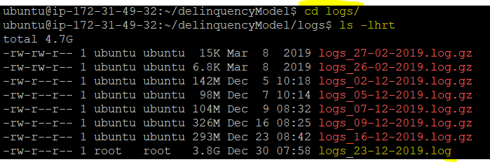

Step -5:

Gzip the log file



Step -6:

After zipped the file, put the following command

* sudo lsof | grep deleted | less



Step -7:

The above command will open the files which are running in background.

Copy the PID number on left side for all the recently deleted files with date.

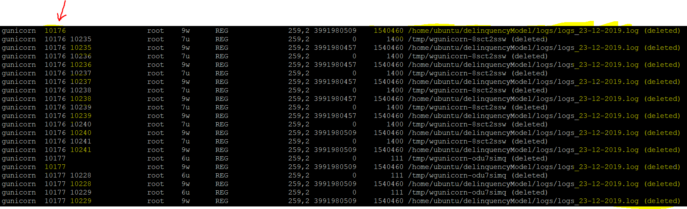

Step -8:

Put the following command.

* sudo kill -9 <PID Numbers which you have copied from the above step>



Follow the same for other two directories.